Portfolio business website

Definition:
# Source: AI Source: Provided by: [Data Path: Persons Table -> ID Column: 1, Name_En Column: Motasem Essam] -> From: [Chatgpt (GPT‑5 Mini)] on [2/12/2026]
A portfolio business website is a website that showcases the work, projects, or achievements of a person or company, often used by freelancers, creatives, or agencies to attract clients.

Simple Definition
# Source: AI Source: Provided by: [Data Path: Persons Table -> ID Column: 1, Name_En Column: Motasem Essam] -> From: [Chatgpt (GPT‑5 Mini)] on [2/12/2026]
Portfolio website = an online showcase of your work to impress clients or employers.

What a Portfolio Business Website Usually Includes
# Source: AI Source: Provided by: [Data Path: Persons Table -> ID Column: 1, Name_En Column: Motasem Essam] -> From: [Chatgpt (GPT‑5 Mini)] on [2/12/2026]
- Home / Introduction – brief overview of you or your business
- Portfolio / Projects – examples of past work with images, videos, or case studies
- Services Offered – what you can do for clients
- About / Bio – personal or company info
- Testimonials / Reviews – client feedback
- Contact / Inquiry Form – lets potential clients reach out

Examples of Portfolio Business Websites
# Source: AI Source: Provided by: [Data Path: Persons Table -> ID Column: 1, Name_En Column: Motasem Essam] -> From: [Chatgpt (GPT‑5 Mini)] on [2/12/2026]
- Freelance designer – showcases graphic design work
- Photographer – displays photos from shoots
- Web developer / software engineer – shows projects and coding work
- Creative agencies – display campaigns, branding, or marketing projects

Purpose of a Portfolio Website
# Source: AI Source: Provided by: [Data Path: Persons Table -> ID Column: 1, Name_En Column: Motasem Essam] -> From: [Chatgpt (GPT‑5 Mini)] on [2/12/2026]
- Showcase skills and projects to potential clients or employers
- Build credibility and personal or company brand
- Attract new clients or job opportunities
- Provide a professional online presence

Difference from Other Websites
# Source: AI Source: Provided by: [Data Path: Persons Table -> ID Column: 1, Name_En Column: Motasem Essam] -> From: [Chatgpt (GPT‑5 Mini)] on [2/12/2026]
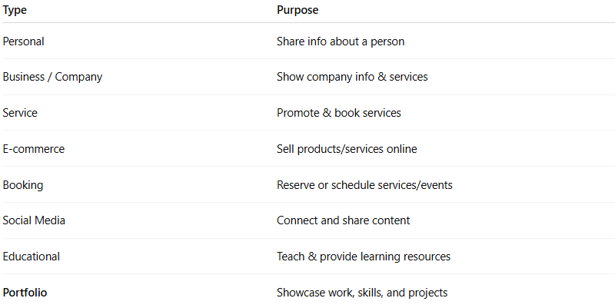
Type | Purpose
Personal | Share info about a person
Business / Company | Show company info & services
Service | Promote & book services
E-commerce | Sell products/services online
Booking | Reserve or schedule services/events
Social Media | Connect and share content
Educational | Teach & provide learning resources
Portfolio | Showcase work, skills, and projects

